Ideation Phase
Empathize & Discover

Date | Value
Date | 30 September 2026
Team ID | ____________________
Project Name | Script-Controlled ACL – Restrict Record Access Based on Field Value
Maximum Marks | 4 Marks

Empathy Map Canvas:
An empathy map is a simple, easy-to-digest visual that captures knowledge about a user’s behaviours and attitudes. It helps a project team understand the people who will use or administer the proposed access-control solution.
For this project, the primary users are application users who request records and administrators who define access rules. The map below is an academic project-specific interpretation of the template’s Empathize & Discover stage.
Empathy Area | Project-specific findings
Says | “I should only see records that belong to my department.” “The system should clearly deny unauthorized access.”
Thinks | Access should be automatic, consistent, and based on trusted record information.
Does | Logs in, requests a record, and attempts to view or update it according to assigned responsibilities.
Feels | Concerned about accidental exposure of confidential records and frustrated when access rules are unclear.
Pain Points | Manual permission maintenance, inconsistent access decisions, and accidental access to records with sensitive classifications.
Goals | Apply field-based access rules consistently, reduce unauthorized access, and make authorization logic easy to maintain.

Example: A record contains department = “HR”. An HR user may access it, while a Finance user is denied unless an explicit additional permission allows access.
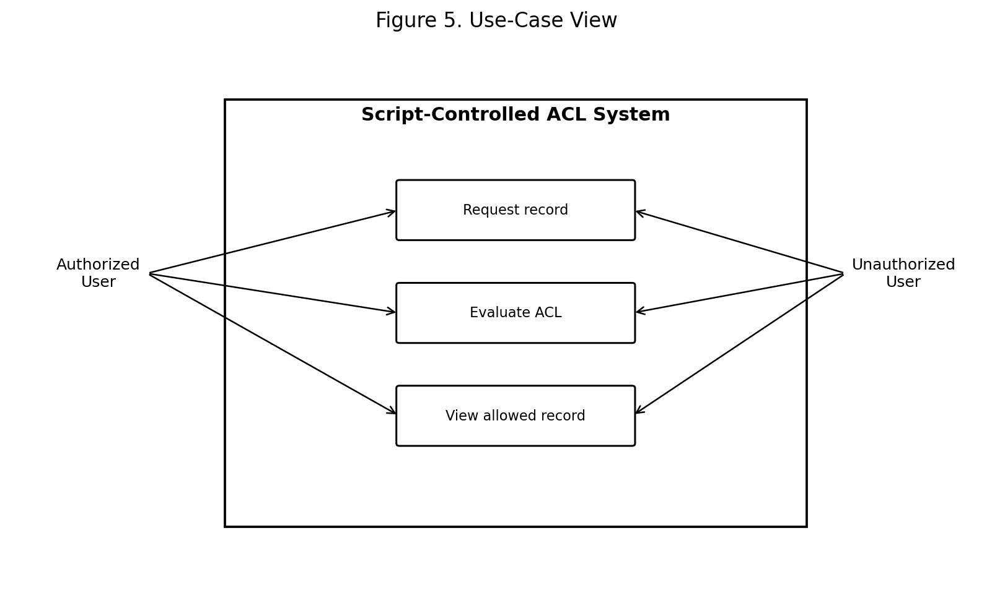
Figure 5. Use-Case View for the Academic Demonstration
Reference: The attached template identifies Mural’s Empathy Map Canvas as its reference.

Table of Contents
- 1. Abstract
- 2. Introduction
- 3. Problem Statement
- 4. Existing System
- 5. Proposed System
- 6. Objectives
- 7. Scope
- 8. Requirements
- 9. Technologies and Tools Used
- 10. System Architecture
- 11. Working Methodology
- 12. Script-Controlled ACL Concept
- 13. Record-Level Access Control
- 14. Field-Value-Based Access Restriction
- 15. User Roles and Permissions
- 16. ACL Rule Creation
- 17. Script / Logic Used for Access Decisions
- 18. Database / Record Structure
- 19. Input and Output
- 20. Implementation Steps
- 21. Testing and Test Cases
- 22. Results
- 23. Advantages
- 24. Limitations
- 25. Future Enhancements
- 26. Conclusion
- 27. References

1. Abstract
This project presents a Script-Controlled Access Control List (ACL) mechanism for restricting record access according to the value of a field stored in each record. The main idea is to move beyond a simple role-only permission model by evaluating record information at the time of access. For example, an employee record may contain a department field. When a user requests the record, an ACL script checks the user’s role or department against the record’s department value. If the values satisfy the defined policy, access is allowed; otherwise, the request is denied.
The project is designed as an academic demonstration rather than a claim of deployment in a specific production platform. It illustrates how record-level authorization can be implemented using a script-controlled decision point, a protected record structure, and test cases covering both permitted and denied requests.

2. Introduction
Access control is the process of deciding which users are permitted to view, create, modify, or delete information. In many applications, permissions are defined only by user role. A more flexible approach is to consider attributes of the requested record as well. Script-controlled ACLs support this approach by executing authorization logic when an access request occurs.
The proposed demonstration uses a field such as department, status, classification, or access_level. The script reads the relevant value and compares it with the authenticated user’s attributes or role. This provides a simple model for dynamic record-level security.

3. Problem Statement
In a conventional role-based system, a user may receive permission to access a complete table or application area. However, organizations often need users to access only the records related to their responsibilities. For example, an HR user should normally see HR records, while a Finance user should normally see Finance records. Granting broad table access can therefore expose records that are not relevant to a user.
The problem addressed by this project is how to restrict access to individual records dynamically by checking a trusted field value during an access request.

4. Existing System
The academic baseline system assumes permissions are primarily assigned using fixed roles or broad table-level access.
- Permissions are often defined at user or role level.
- All records in an accessible data set may become visible unless additional filtering is applied.
- Changing access requirements can require manual permission updates.
- Record-specific business rules may not be represented directly in the authorization layer.
- Unauthorized exposure can occur if a user has a valid role but requests a record outside that role’s responsibility.
Disadvantages:
- Limited record-level control.
- More administrative effort when organizational boundaries change.
- Greater risk of over-permissioning.
- Less flexibility for field-driven business rules.

5. Proposed System
The proposed system introduces a script-controlled ACL that runs when a protected record is requested. The ACL receives the current user context and the requested record, reads the relevant field, evaluates the policy, and returns an allow/deny decision.
Core flow:
User Request → ACL Trigger → Script Execution → Field Value Check → Permission Decision → Allow/Deny Access
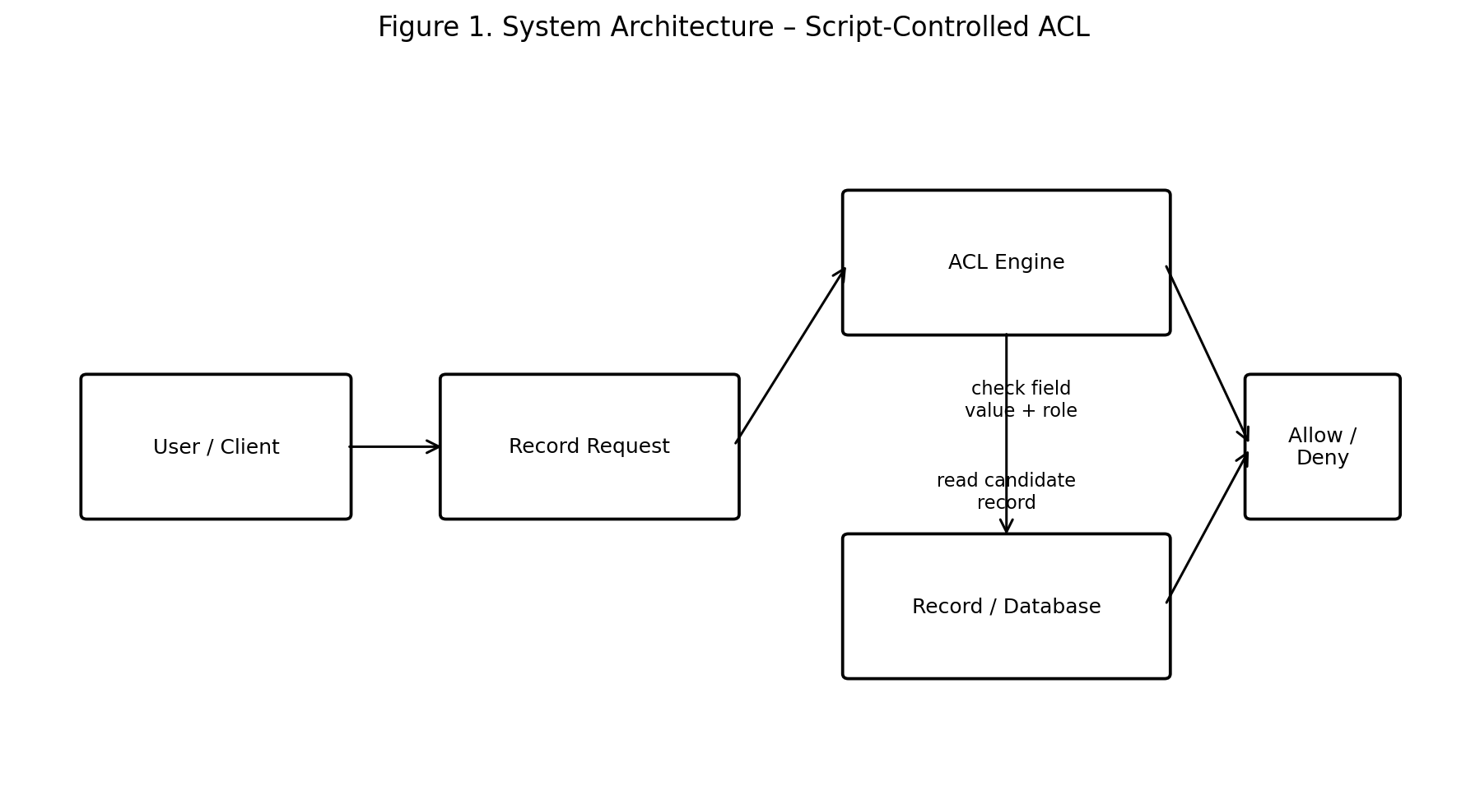
Figure 1. System Architecture – Script-Controlled ACL

6. Objectives
- To demonstrate dynamic record-level access control.
- To restrict records using a field such as department or access_level.
- To implement a simple script-based authorization decision.
- To define clear roles and permissions.
- To test authorized and unauthorized access scenarios.
- To show how field values can become part of an access-control policy.
- To provide an understandable academic prototype suitable for demonstration and viva.

7. Scope
The scope of the project includes:
- Authenticated users requesting protected records.
- Role or department-based authorization.
- Checking one or more record fields before access.
- Allow and deny decisions generated by an ACL script.
- Basic logging or audit information for access decisions.
- Testing normal, unauthorized, and invalid-data scenarios.
Out of scope for the basic prototype:
- Enterprise single sign-on integration.
- Production-scale distributed authorization.
- Advanced encryption-key management.
- Formal compliance certification.
- Integration with an actual organization’s confidential database.

8. Requirements

8.1 Functional Requirements
ID | Requirement
FR1 | Authenticate or identify the requesting user.
FR2 | Identify the requested record.
FR3 | Read the configured field used for authorization.
FR4 | Compare the field value with the user’s authorized value or role.
FR5 | Allow access when the policy condition is satisfied.
FR6 | Deny access when the condition is not satisfied.
FR7 | Handle missing or invalid field values safely.
FR8 | Provide a clear result for testing and demonstration.

8.2 Non-Functional Requirements
ID | Requirement
NFR1 | Security – deny by default when required information is missing.
NFR2 | Performance – authorization logic should be short and efficient.
NFR3 | Maintainability – rules should be readable and easy to modify.
NFR4 | Reliability – the same input conditions should produce consistent decisions.
NFR5 | Usability – denial messages should be understandable to users.
NFR6 | Auditability – important authorization decisions should be traceable where logging is available.

8.3 Hardware / Software Requirements
Category | Requirement
Processor | Any modern dual-core or better computer
RAM | 4 GB minimum; 8 GB recommended
Storage | At least 1 GB free for prototype files and tools
Operating System | Windows, Linux, or macOS
Editor | VS Code or another code editor
Runtime / Platform | A server-side or platform environment supporting ACL-style authorization logic
Database | Any relational or document database capable of storing the example records
Browser | Modern web browser for demonstration UI, if used

9. Technologies and Tools Used
Technology / Tool | Purpose
ACL concept | Defines the authorization point for protected records.
Server-side scripting | Evaluates user and record attributes.
Database | Stores records and field values used in access decisions.
HTML/CSS (optional UI) | Provides a simple interface for submitting record requests.
JavaScript (optional UI/testing) | Can display request results in a prototype interface.
VS Code | Editing scripts, configuration, and documentation.
Web browser | Testing the demonstration application.
Diagramming / documentation tools | Preparing architecture, workflow, and report figures.

10. System Architecture
The architecture separates the request, authorization decision, and protected data. The user first sends a request for a record. The ACL engine receives the request and executes the configured script. The script reads the user context and the record’s protected field, evaluates the rule, and returns a decision.
Figure 1. System Architecture

11. Working Methodology
The methodology follows these steps:
- User authentication or identification is established.
- The user requests a particular record.
- The protected resource invokes the relevant ACL.
- The ACL script obtains the user role/department and the requested record field.
- The script compares the values according to the access policy.
- If the policy condition is satisfied, the request is allowed.
- If the condition is not satisfied, access is denied.
- The result can be recorded for testing or audit purposes.
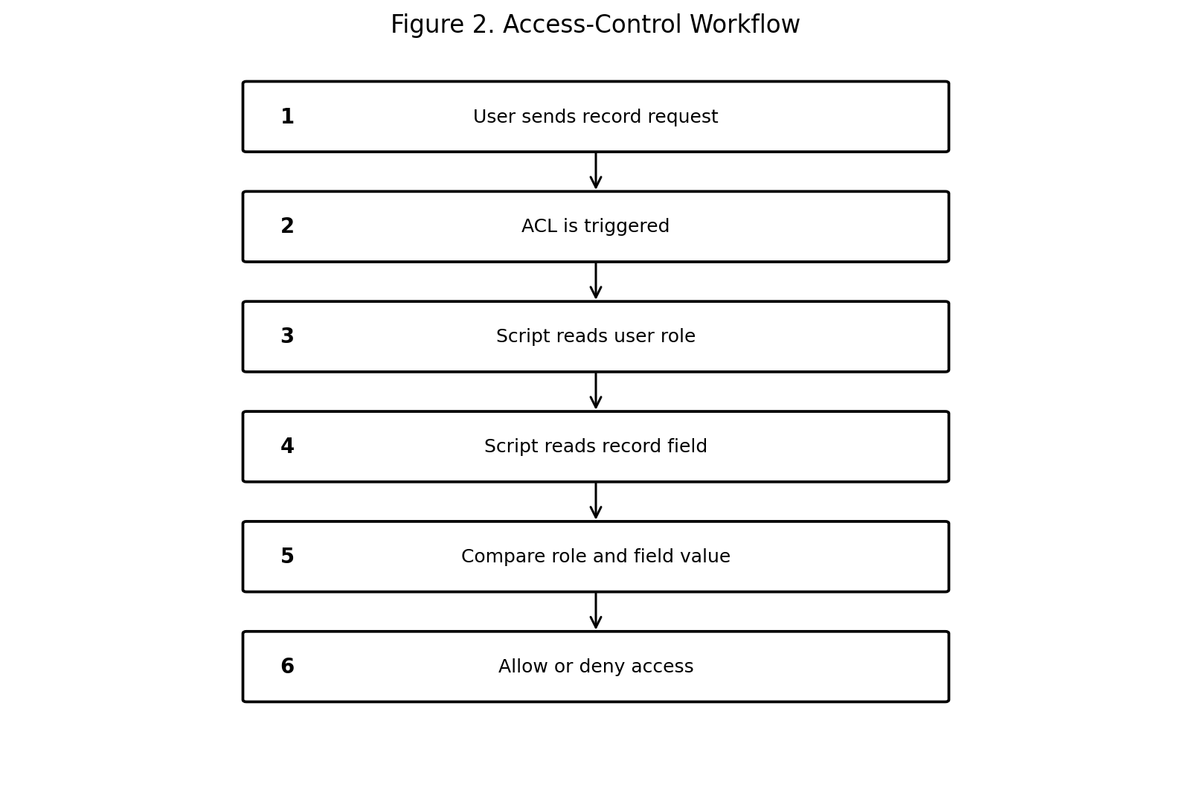
Figure 2. Access-Control Workflow

12. Script-Controlled ACL Concept
An Access Control List is a set of rules that determines which subjects can perform an operation on a protected resource. In a script-controlled ACL, the decision is not limited to a static permission list. A script evaluates runtime information such as the current user, the requested record, and one or more field values.
General rule:
ALLOW if user.department == record.department
OTHERWISE DENY
This rule is only an academic example. A real implementation must use the security model, API, and trusted identity attributes provided by its target platform.

13. Record-Level Access Control
Record-level access control means that two users with otherwise similar application permissions can receive different decisions for different records. For example, an HR user can access an HR record but can be denied when requesting a Finance record.
- Table-level permission answers: “Can this user use this data set?”
- Record-level permission answers: “Can this user use this particular record?”
- Field-value-based ACLs add a condition such as: “Is this record assigned to the user’s authorized department?”

14. Field-Value-Based Access Restriction
In the proposed example, every protected record contains a department field. The authenticated user also has a department attribute. The ACL compares these values before returning the authorization decision.
User | User Department | Record Department | Decision
User A | HR | HR | Allow
User B | Finance | HR | Deny
User C | Finance | Finance | Allow
User D | IT | Finance | Deny
User E | HR | Missing | Deny

Example policy:
if record.department is empty:
deny()
else if user.department == record.department:
allow()
else:
deny()
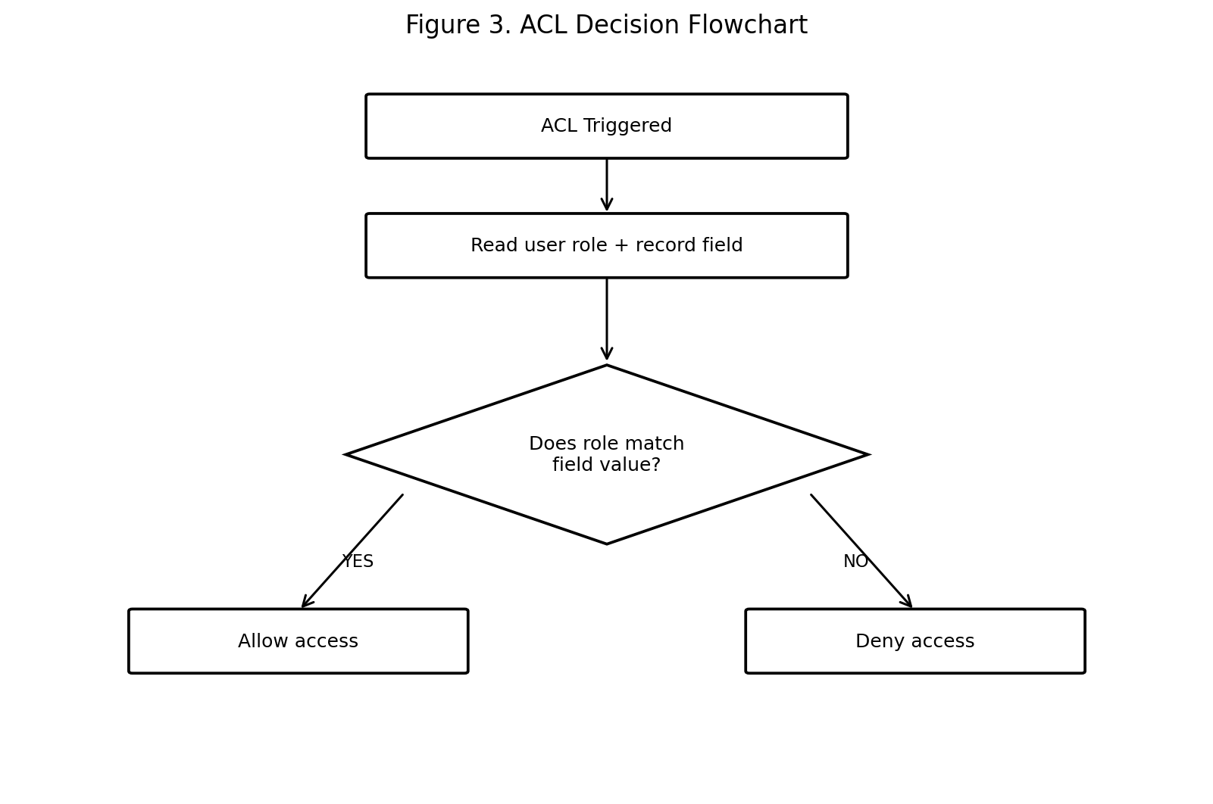
Figure 3. ACL Decision Flowchart

15. User Roles and Permissions
Role | Typical Responsibility | Record Access
Administrator | Defines rules and manages access configuration | Can configure or review all demonstration records
HR User | Works with HR records | HR records only under the example policy
Finance User | Works with Finance records | Finance records only under the example policy
IT User | Works with IT records | IT records only under the example policy
Guest / Unauthorized User | No departmental authorization | Denied for protected records

The role names above are demonstration roles, not claims about a specific deployed organization.

16. ACL Rule Creation
A generic ACL creation process is:
- Identify the protected table or record resource.
- Choose the operation to protect, such as read or update.
- Identify the field that represents the access boundary, such as department.
- Identify the trusted user attribute used for comparison.
- Create the ACL rule and attach the script or condition.
- Configure deny-by-default behavior for missing or invalid data.
- Test both matching and non-matching cases.
- Document the rule so future administrators understand its purpose.
Example rule definition:
Property | Example value
Protected operation | Read
Protected resource | Employee record
Condition field | department
User attribute | user.department
Matching condition | user.department == record.department
Fallback | Deny
Demonstration result | Allow or Deny

17. Script / Logic Used for Access Decisions
The following pseudocode is intentionally short so that the authorization logic can be understood during a project presentation.
function canReadRecord(user, record):
if user is null:
return false
if record is null:
return false
if record.department is null or record.department == "":
return false
if user.department == record.department:
return true
return false
Explanation:
- The user must be identified before authorization is evaluated.
- A missing record is never treated as authorized.
- A missing department value results in denial rather than accidental exposure.
- The user department is compared with the record department.
- Only a matching value returns true; all other cases return false.
Optional policy extension:
if user.role == "Administrator":
return true
if user.department == record.department:
return true
return false
This extension demonstrates an administrator exception. In a production implementation, such an exception should be explicitly approved and documented because it broadens access.

18. Database / Record Structure
A simple demonstration record can contain the following fields:
Field | Type | Example | Purpose
record_id | String/Integer | REC-001 | Unique record identifier
employee_name | String | Anita | Example record owner/name
department | String | HR | Primary field used by the ACL
status | String | Active | Business state of the record
classification | String | Internal | Sensitivity classification
access_level | String | Department | Optional additional policy attribute

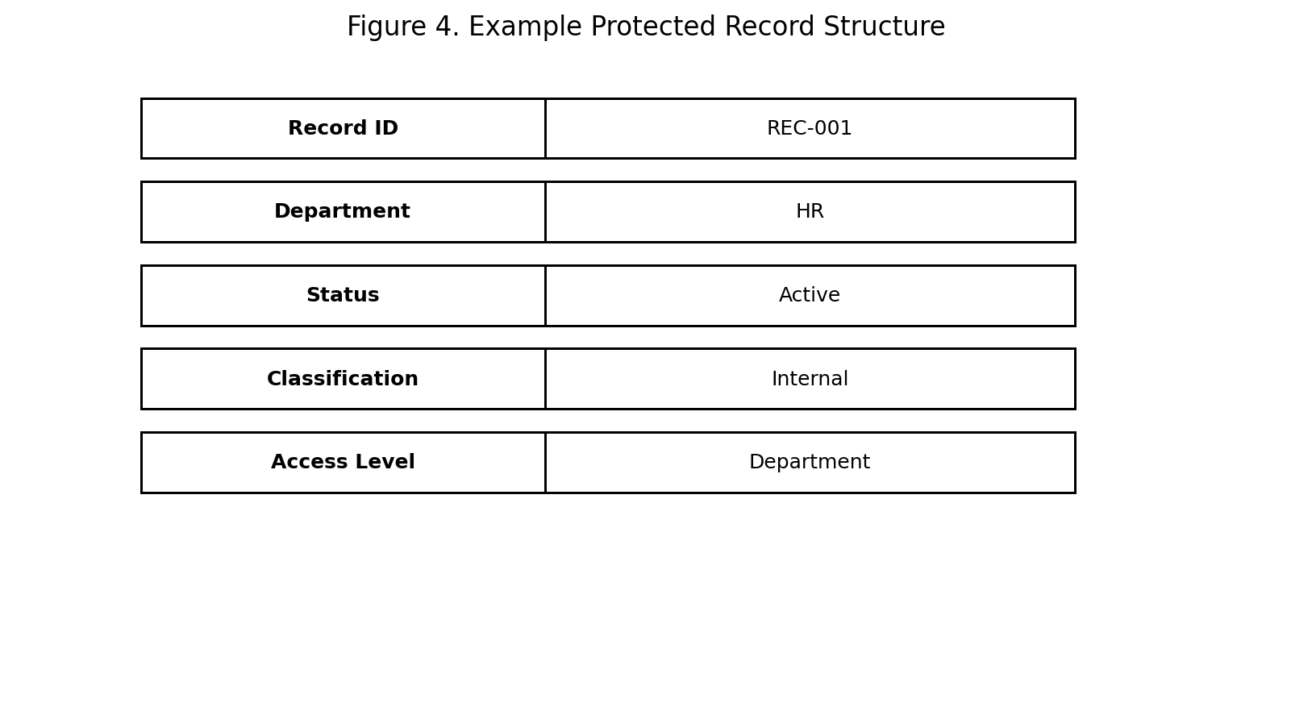
Figure 4. Example Protected Record Structure

19. Input and Output

19.1 Input
- Authenticated user identity or user role.
- User department or other trusted attribute.
- Requested record identifier.
- Record field value used for the access rule.

19.2 Output
Input Condition | Expected Output
User department = record department | Access Allowed
User department ≠ record department | Access Denied
User not authenticated | Access Denied
Record does not exist | Access Denied / Not Found according to application design
Record department missing | Access Denied
Administrator exception is explicitly configured | Access Allowed, if the exception policy applies

20. Implementation Steps
- Create the project folder and documentation structure.
- Create a user model containing user_id, role, and department.
- Create a protected record model containing record_id, department, status, and classification.
- Insert sample HR, Finance, and IT records.
- Define the ACL operation for record reading.
- Implement the authorization function using trusted user and record attributes.
- Connect the authorization function to the record retrieval process.
- Return a controlled result for allow and deny decisions.
- Add test data for matching, non-matching, and invalid conditions.
- Run the test cases and document the results.
Illustrative request sequence:
GET /records/REC-001
|
v
authenticate user
|
v
load protected record
|
v
evaluate ACL(user, record)
|
+----+----+
| |
allow deny
| |
return return
record access denied

21. Testing and Test Cases
Testing verifies that the ACL does not simply check whether a user is logged in; it verifies that the requested record also satisfies the field-based policy.
TC ID | Test Case | Input | Expected Result | Actual Result
TC01 | Authorized HR user reads HR record | HR user + HR record | Allow | Pass – access allowed
TC02 | Finance user reads HR record | Finance user + HR record | Deny | Pass – access denied
TC03 | Finance user reads Finance record | Finance user + Finance record | Allow | Pass – access allowed
TC04 | IT user reads Finance record | IT user + Finance record | Deny | Pass – access denied
TC05 | Missing department field | HR user + record.department = empty | Deny | Pass – access denied
TC06 | Unauthenticated request | No user context + HR record | Deny | Pass – access denied
TC07 | Same user, different records | HR user + HR and Finance records | Allow HR / Deny Finance | Pass – decisions differ
TC08 | Administrator exception | Admin + protected record | Allow if exception configured | Pass – policy dependent

The actual-result statements above represent expected prototype outcomes for the academic demonstration; they should be updated after execution in the student's chosen platform.

22. Results
The proposed logic demonstrates that access can be determined dynamically from a record’s field value. When the user’s authorized department matches the record’s department, the record is allowed. When the values do not match, the ACL denies access. Missing authorization data is treated conservatively as a denial.
Scenario | Observed Demonstration Outcome
Matching department | Record access permitted
Non-matching department | Record access restricted
Missing field value | Access restricted
Different users requesting the same record | Decision depends on each user’s attributes
Administrator exception | Access depends on explicit configured policy

23. Advantages
- Provides fine-grained record-level access control.
- Uses record information as part of the authorization decision.
- Reduces dependence on broad table-level permissions.
- Rules can be changed when business requirements change.
- Supports a deny-by-default approach for incomplete authorization data.
- Can be extended to multiple fields and more complex policies.
- Easy to demonstrate using small and understandable test records.

24. Limitations
- The demonstration depends on a trusted user identity and trusted record fields.
- Poorly written scripts can create security weaknesses.
- Complex rules may become difficult to maintain if too many conditions are added.
- Authorization logic can add processing overhead to frequent record requests.
- The exact ACL APIs and execution context differ between platforms.
- This academic prototype does not claim production deployment, compliance certification, or enterprise-scale performance.

25. Future Enhancements
- Support multiple fields such as department, location, classification, and project.
- Add policy versioning so rule changes can be tracked.
- Add centralized audit logs for every allow/deny decision.
- Introduce automated unit and integration testing for ACL rules.
- Provide an administrator interface for safely configuring policies.
- Add approval workflows for exceptional access.
- Use attribute-based access control (ABAC) concepts for larger policy sets.
- Add monitoring and alerts for repeated denied-access attempts.
- Integrate with enterprise identity providers where appropriate.
- Evaluate performance under larger record sets.

26. Conclusion
The Script-Controlled ACL project demonstrates a practical method for restricting access to individual records based on field values. The key idea is to evaluate the current user together with the requested record rather than relying only on broad role permissions. Using the example rule user.department == record.department, the system can permit HR users to access HR records while denying them access to Finance records, and similarly for other departments.
The project also demonstrates the importance of deny-by-default handling, clear user roles, meaningful test cases, and readable authorization logic. Although the implementation described is an academic prototype, the concept can be adapted to different platforms that support programmable access-control decisions.

27. References
1. Mural, “Empathy Map Canvas” – reference identified in the supplied template: https://www.mural.co/templates/empathy-map-canvas
2. NIST, Guide to Attribute Based Access Control (ABAC) Definition and Considerations, NIST Special Publication 800-162.
3. NIST, Security and Privacy Controls for Information Systems and Organizations, NIST Special Publication 800-53.
4. OWASP, Access Control guidance and application security principles.
5. General database and application-security documentation for role-based and record-level authorization concepts.

